package com.torryharris;

public class Main {  
  
 public static void main(String[] args) {  
 for(int i=0;++i<=10;i++)  
 {  
 System.*out*.println(i);  
 }

package com.torryharris;  
  
public class Main {  
  
 public static void main(String[] args) {  
 for(int i=0;++i<=10;i++)  
 {  
 System.*out*.println(i);  
 }  
  
 for(int i=0;i++<=10;i++)  
 {  
 System.*out*.println("decrement" +i);  
 }  
 //Find the minimum and maximum  
 int[] arr={213,5555,6789,10000,55,99,41,999};  
 int max=arr[0];  
 int min=arr[0];  
 for(int i=1;i<arr.length;i++)  
 {  
 if(arr[i]>max)  
 max=arr[i];  
 if(arr[i]<min)  
 min=arr[i];  
 }  
 System.*out*.println(max+" maximum no.\n"+min+" minimum no.");  
 }  
}

**OUTPUT:**

1

3

5

7

9

decrement1

decrement3

decrement5

decrement7

decrement9

decrement11

10000 maximum no.

41 minimum no.

**String functions in java:**

package com.torryharris;  
  
public class Main {  
  
 public static void main(String[] args) {  
 String str1 = args[0];  
 String str2 = args[1];  
 System.*out*.println(str1+" "+str2+".Have a nice day");  
 }  
}

**OUTPUT:**

Happy morning.Have a nice day

**(BUBBLE SORT)**

package com.torryharris;  
  
import java.util.Scanner;  
  
public class Main {  
  
 public static void main(String[] args) {  
  
 Scanner sc = new Scanner(System.*in*);  
 int len = Integer.*parseInt*(args[0]);  
  
 int[] arr = new int[len];  
  
  
 System.*out*.println("Enter the elements in the array");  
 for ( int i=0;i<arr.length;i++)  
 {  
 arr[i]=sc.nextInt();  
 }  
 for (int i=0;i<(arr.length-1);i++)  
 {  
 for (int j=0;j<(arr.length-i-1);j++)  
 {  
 if (arr[j]>arr[j+1])  
 {  
 int temp = arr[j];  
 arr[j] = arr[j+1];  
 arr[j+1]=temp;  
 }  
 }  
  
 }  
 System.*out*.println("Printing the elements of the array");  
 for (int i=0;i<arr.length;i++)  
 {  
 System.*out*.print(arr[i]+" ");  
 }  
 System.*out*.println(); }  
}

**PROGRAM DONE BY USING OBJECT AND CLASS METHOD**

**1)**

**BOOK .JAVA**

package com.torryharris;  
  
public class book {  
 int book_ID;  
 String book_name;  
 int book_price;  
  
 public book(int book_ID, String book_name, int book_price) {  
 this.book_ID = book_ID;  
 this.book_name = book_name;  
 this.book_price = book_price;  
 }  
  
 @Override  
 public String toString() {  
 return "book{" +  
 "book_ID=" + book_ID +  
 ", book_name='" + book_name + '\'' +  
 ", book_price=" + book_price +  
 '}';  
 }  
}  
**Main java**

package com.torryharris;  
  
public class Main {  
  
 public static void main(String[] args) {  
 book book1 = new book(100 , "java" , 300);  
 System.*out*.println(book1);  
 }  
}

**Output:**

book{book_ID=100, book_name='java', book_price=300}

package com.torryharris;  
  
import java.util.Scanner;  
  
public class Main {  
  
 public static void main(String[] args) {  
 Scanner sc = new Scanner(System.*in*);  
 System.*out*.println("Enter the details of the book1");  
 int book_Id1= sc.nextInt();  
 String book_name1 = sc.next();  
 int book_price1 = sc.nextInt();  
  
 book book1 = new book(book_Id1,book_name1,book_price1);  
  
  
 System.*out*.println("Enter the details of the book1");  
 int book_Id2= sc.nextInt();  
 String book_name2 = sc.next();  
 int book_price2 = sc.nextInt();  
  
 book book2 = new book(book_Id2,book_name2,book_price2);  
  
  
 System.*out*.println("Enter the details of the book3");  
 int book_Id3= sc.nextInt();  
 String book_name3 = sc.next();  
 int book_price3 = sc.nextInt();  
  
 book book3 = new book(book_Id3,book_name3,book_price3);  
  
 System.*out*.println(book1);  
 System.*out*.println(book2);  
 System.*out*.println(book3);  
  
 }  
}

**output:**

Enter the details of the book1

100

new

300

Enter the details of the book1

101

good

500

Enter the details of the book3

102

super

1000

book{book_ID=100, book_name='new', book_price=300}

book{book_ID=101, book_name='good', book_price=500}

book{book_ID=102, book_name='super', book_price=1000}

package com.torryharris;  
  
import java.util.Scanner;  
  
public class Main {  
  
 public static void main(String[] args) {  
   
 Scanner sc =new Scanner(System.*in*);  
 System.*out*.println("Enter the no. of books");  
 int len =sc.nextInt();  
 int[] arr = new int[len];  
 book[] bookarr = new book[len];  
 for (int i=0;i<bookarr.length;i++)  
 {  
 System.*out*.println("Enter the details of the book1"+(i+1));  
 int book_Id= sc.nextInt();  
 String book_name = sc.next();  
 int book_price = sc.nextInt();  
 bookarr[i]=new book(book_Id,book_name,book_price);  
 }

/*System.out.println("print the book");  
 for (int i=0;i<bookarr.length;i++)  
 {  
 System.out.println(bookarr[i]);  
 }*/

for (book book:bookarr)  
 {  
 System.*out*.println(book);  
 }  
 }  
}

**output:**

Enter the no. of books

3

Enter the details of the book11

1

java

200

Enter the details of the book12

2

html

300

Enter the details of the book13

4

css

500

book{book_ID=1, book_name='java', book_price=200}

book{book_ID=2, book_name='html', book_price=300}

book{book_ID=4, book_name='css', book_price=500}

**student.java**

package com.torryharris;  
  
public class student {  
 String student_name;  
 int regno;  
 int subm1;  
 int subm2;  
 int subm3;  
  
 public student(String student_name, int regno, int subm1, int subm2, int subm3) {  
 this.student_name = student_name;  
 this.regno = regno;  
 this.subm1 = subm1;  
 this.subm2 = subm2;  
 this.subm3 = subm3;  
 }  
 private double calc_percentage(){  
 return ((subm1+subm2+subm3)/3);  
 }  
 @Override  
 public String toString() {  
 return "student{" +  
 "student_name='" + student_name + '\'' +  
 ", regno=" + regno +  
 ", subm1=" + subm1 +  
 ", subm2=" + subm2 +  
 ", subm3=" + subm3 +"Percentage : "+calc_percentage()+  
 '}';  
 }  
}  
**main**

package com.torryharris;  
  
public class Main {  
  
 public static void main(String[] args) {  
 student student1 = new student("priya",15,100,98,95);  
 System.*out*.println(student1);  
 }  
}

**output**

student{student_name='priya', regno=15, subm1=100, subm2=98, subm3=95Percentage : 97.0}

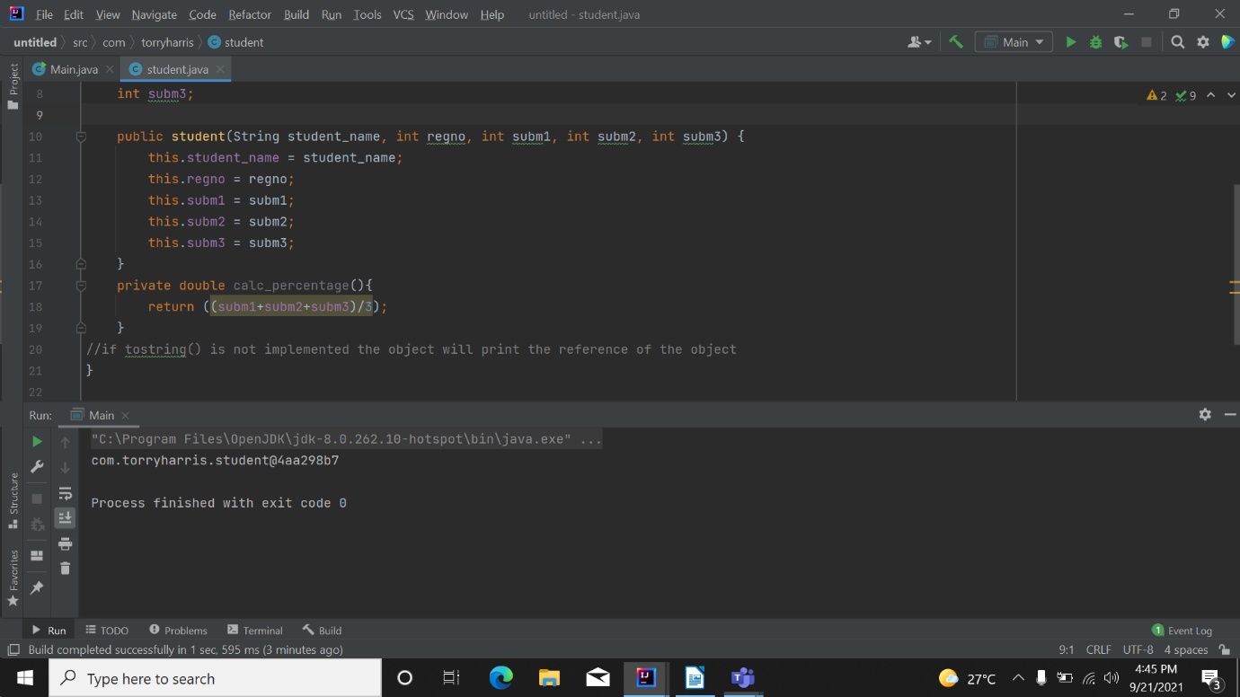

**Customer.java**

package com.torryharris;  
  
public class customer {  
 private int cust_id;  
 private String customer_Name;  
 private int unitsconsumed;  
 private int unitprice;  
  
 public customer(int cust_id, String customer_Name, int unitsconsumed, int unitprice) {  
 this.cust_id = cust_id;  
 this.customer_Name = customer_Name;  
 this.unitsconsumed = unitsconsumed;  
 this.unitprice = unitprice;  
 }  
 private int calc_billamnt()  
 {  
 return (unitsconsumed*unitprice);  
 }  
  
 @Override  
 public String toString() {  
 return "customer{" +  
 "cust_id=" + cust_id +  
 ", customer_Name='" + customer_Name + '\'' +  
 ", unitsconsumed=" + unitsconsumed +  
 ", unitprice=" + unitprice +" Bill amount : " +calc_billamnt()+  
 '}';  
 }  
}

**main**

package com.torryharris;  
  
public class Main {  
  
 public static void main(String[] args) {  
 customer c1 = new customer(1,"priya",480,5);  
  
 //System.out.println("Bill amount: " + c1.calc_billamnt());  
 System.*out*.println(c1);  
 }  
}

**output:**

customer{cust_id=1, customer_Name='priya', unitsconsumed=480, unitprice=5 Bill amount : 2400}